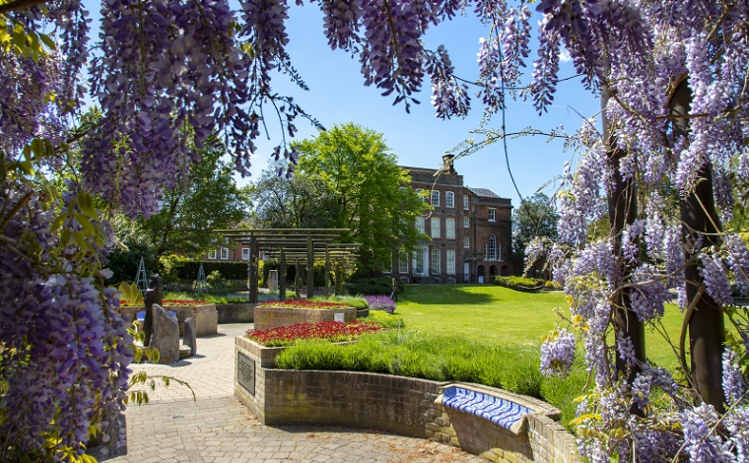
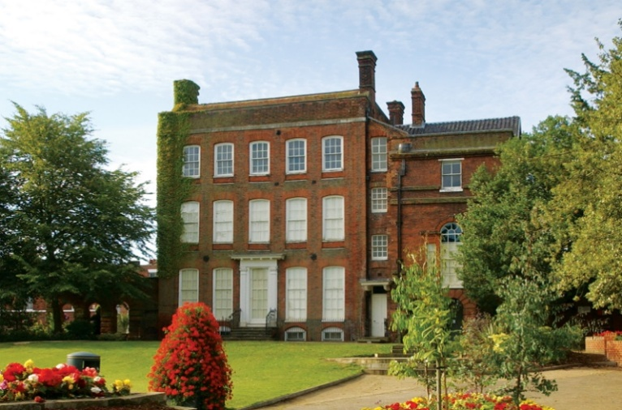

In front of Hollytrees Museum is sensory garden and a large lawn. You might see and hear other people, and smell the flowers.
Behind the Museum is a road, so you may see and hear traffic.


Hollytrees Museum is inside a three-storey, red brick house.
The Museum has displays of toys, paintings and household objects. There is currently a large dinosaur skeleton on display.
There are things to see, hear and feel inside Hollytrees Museum.

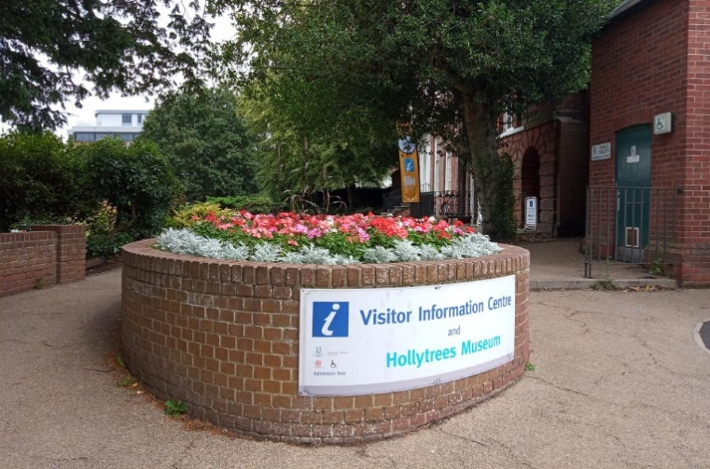
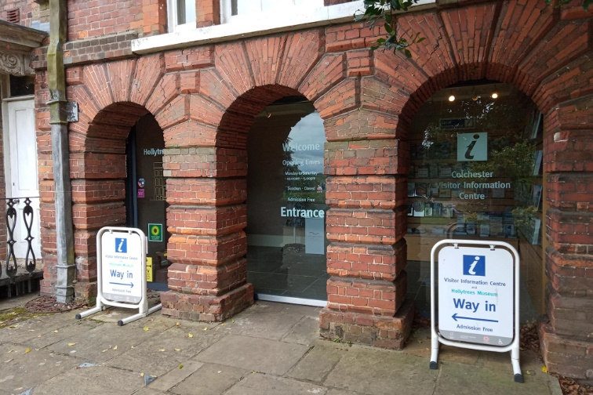

You enter Hollytrees Museum by walking along a paved path.
The building is also home to Colchester’s Tourist Information Centre.
It may look dark as you approach the automatic door but there are lights inside.

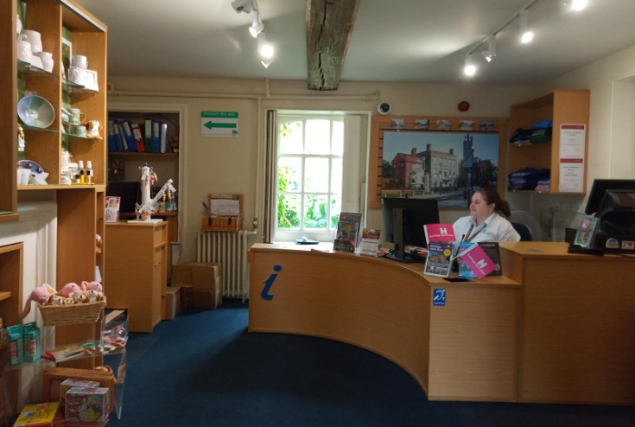
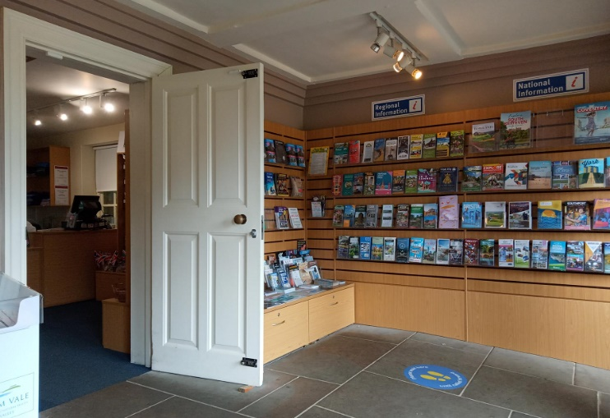

Beyond the lobby is the Tourist Information Centre.
At the Welcome desk you will see a member of the Tourist Information team. They will be wearing a uniform and are there to help you.
There may be a queue of people and this area may be busy.
Hollytrees Museum is through another door.

Just inside the front door is a lobby area with lots of leaflets on display.
You may hear other visitors who are already inside the Museum.

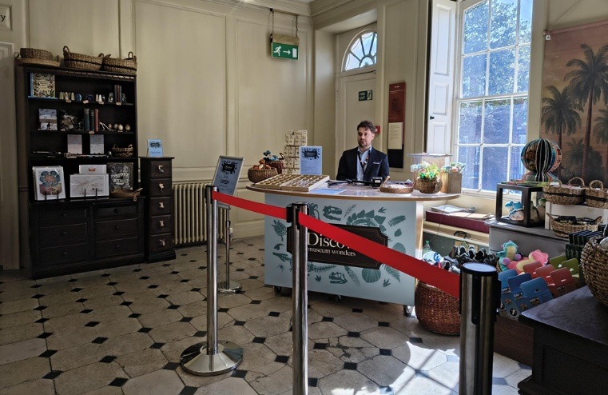

Past the Tourist Information Centre is the Hollytrees Museum Hall.
There is an information desk and shop with dinosaur-themed things for sale.
A member of staff in uniform will be there to help you.
Large windows let in light from outside.
Doors lead to the Garden Room and the Bernard Mason Clock Gallery, and there are stairs to the first floor.

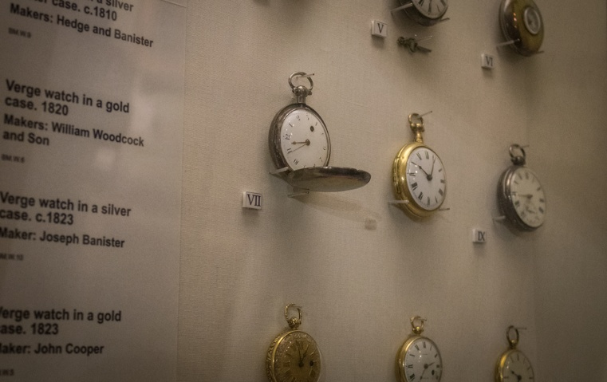
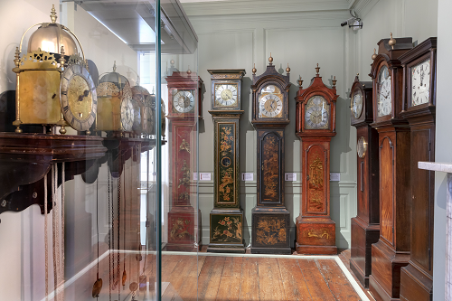

The Bernard Mason Clock Gallery contains lots of different sized clocks.
You might hear ticking sounds in this room. You might also hear creaking from the wooden floorboards.
The light in this room is quite dim.

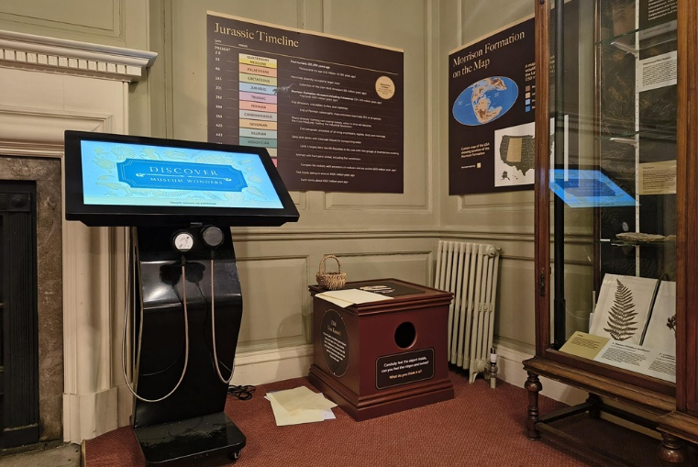
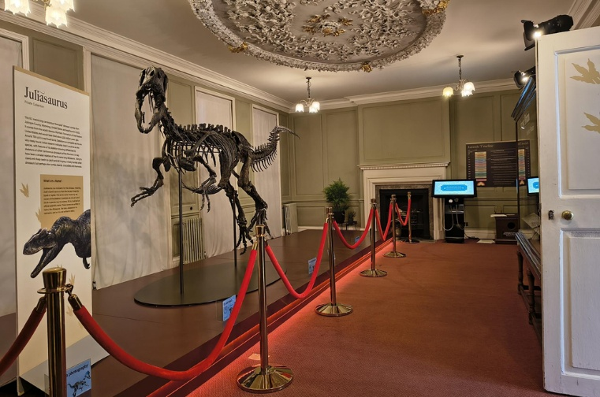

The Garden Room contains an exhibition called ‘Discover: Museum Wonders’. The exhibition is about dinosaurs and a large skeleton is behind a rope.
There are display cases with fossils to look at.
There is a touch screen with more information and pictures.
There is also a ‘feelie’ box you can put your hand inside and a textured picture on the top you can touch.
A Museum volunteer may be in this room. They will know more about the exhibition and are there to help.
This room may be busy at times.

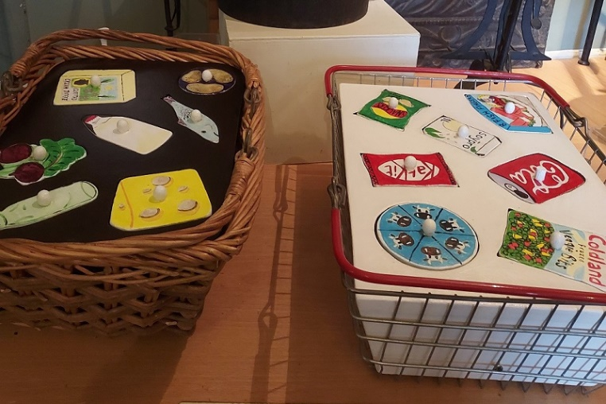
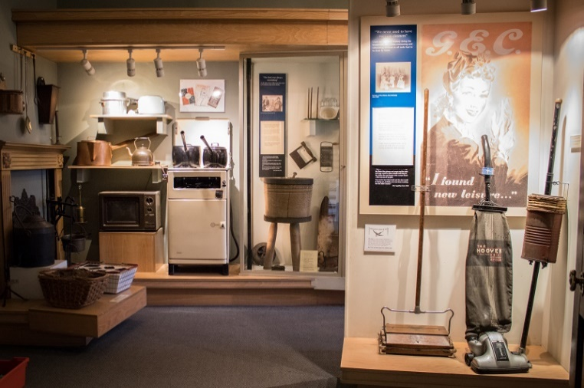

The Running The Home gallery is on the first floor and contains household items.
Some displays you can touch and there is a telephone where you can hear people talking.

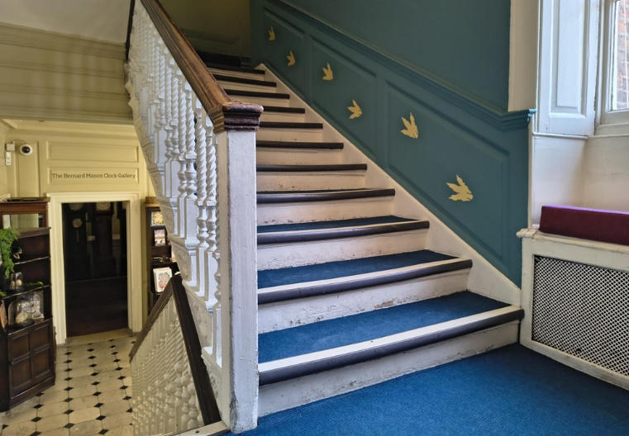

On the stairs and second floor landing you might see dinosaur prints on the wall.
Sometimes the stairs will make a creaking sound.

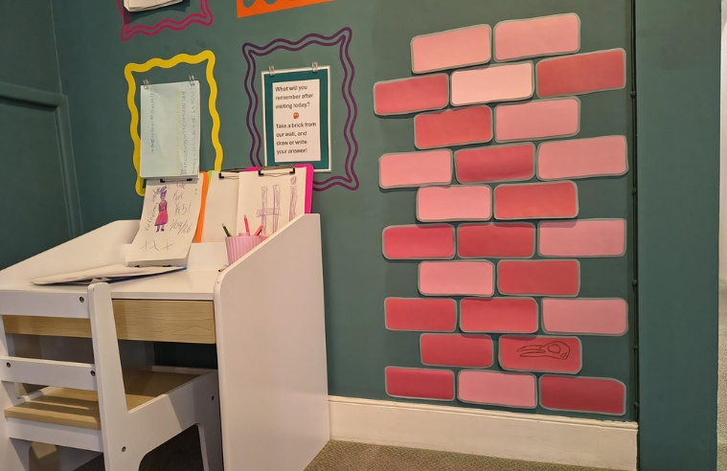
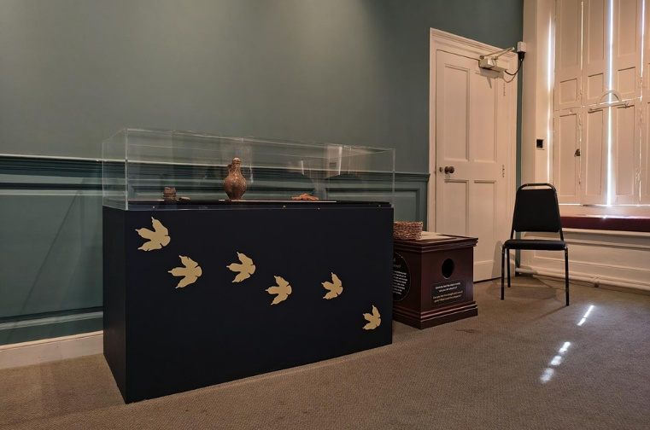

The second floor landing contains another display case for the ‘Discover: Museum Wonders’ exhibition.
There is also an area where you can draw, try on fancy dress and sit on bean bags.

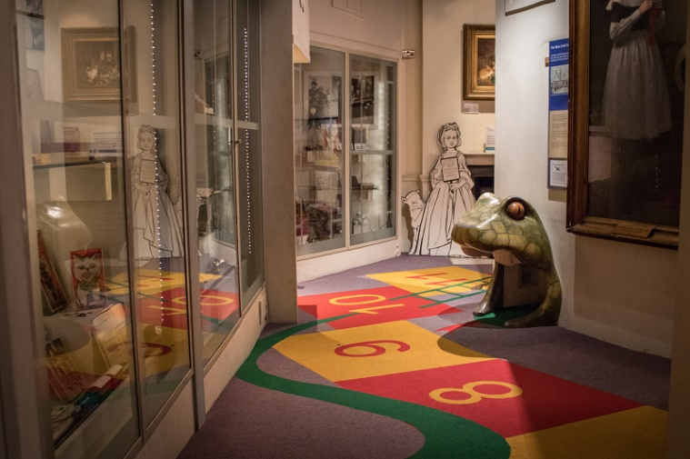

The Childhood Gallery is on the second floor and contains lots of toys in display cases.
The floor has coloured numbers and you can crawl through a snake tunnel.
There are toys you can play with and books to read.
You might hear music playing and the floor creaking.

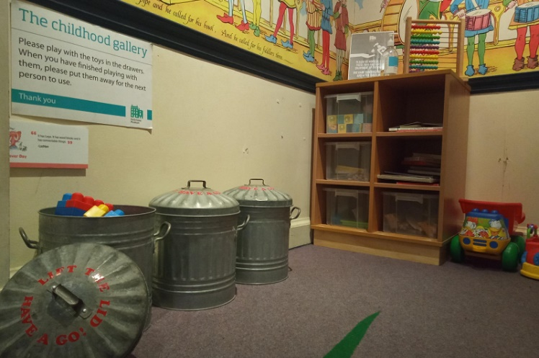

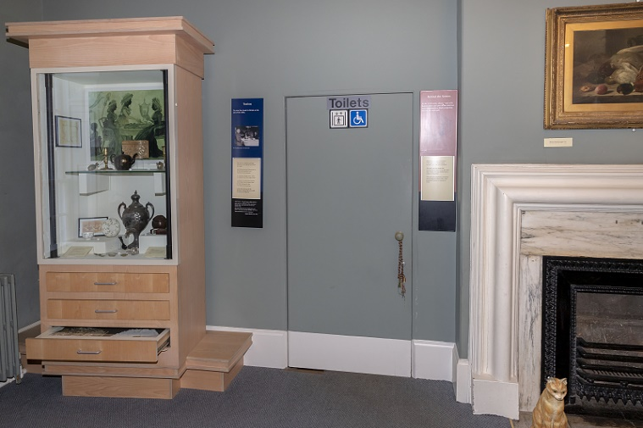

Hollytrees Museum has a lift, which you can enter from the lobby area, the Garden Room, the Running The Home Gallery or the Childhood Gallery.

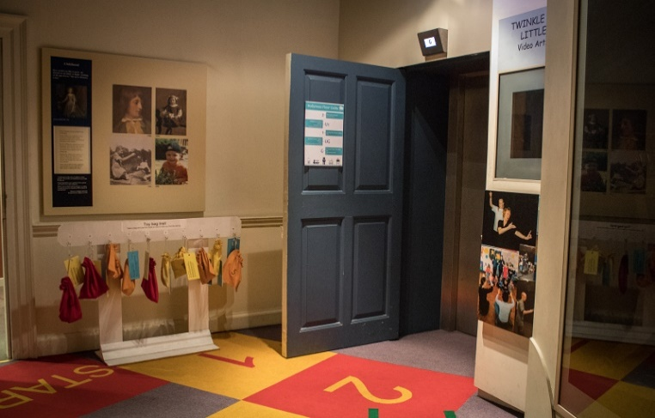

The toilet is through the Running The Home Gallery on the first floor.
Everyone is welcome to use this toilet.
There are paper towels available to dry your hands. The toilet does not have a hand dryer.

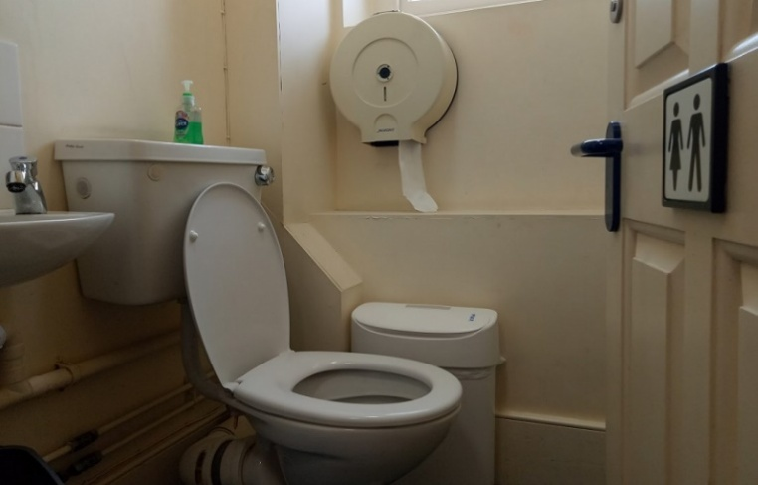

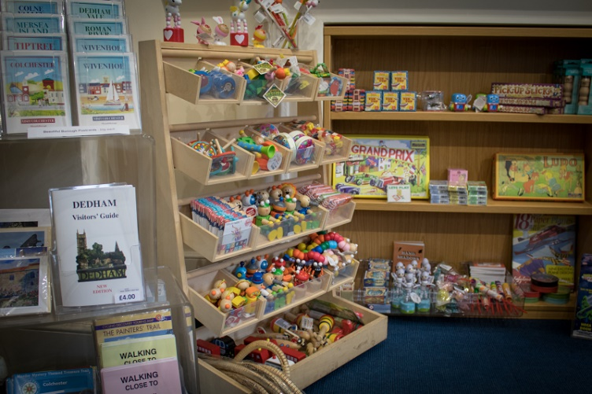

To exit the museum, you have to go back through the reception and shop.
You can buy souvenirs from the staff at the Welcome desk.
There may be a queue of people and this area may be busy.

